Term Paper: Agent Based System/Technology

Priyanka Das
Roll No.: 91/CIS/091028
Regn No.: 0063688 of 2006-07

&

Angana Chakraborty
Roll No.: 91/CIS/091029
Regn No.: 0063692 of 2006-07

Under the Guidance of

Dr. Sankhayan Choudhury

Associate Professor
Department of Computer Science & Engineering
University of Calcutta



M.Sc (Computer And Information Science) 4th Semester 2011
Department of Computer Science & Engineering
University Of Calcutta

Agent Technology: An overview

In this section we have tried to provide an overview of agent technology. In the above section we have discussed how the cloud computing provide scalable, dynamic resource provisioning. However one of the major challenge lies in scalability and automation of these service provisioning. During the project we have studied that mobile agent is able to dynamically add and configure services on the virtual cluster and grid computing. This section we have tried to experiment whether the dynamic properties of agent technology well fulfills the need of efficient service provisioning in cloud environment.

Agent Technology: Definition

An agent is a computer system capable of flexible autonomous action in a dynamic, unpredictable and open environment. Agent technologies are a natural extension of current component based approaches, and have the potential to greatly impact the lives and work of all of us and, accordingly, this area is one of the most dynamic and exciting in computer science today.

About an Agent

Some developers consider agents to be objects, except with more bells and whistles. Then, there are those who see agents and objects as different even though they share many things in common. Both approaches, however, envision using objects and agents together in the development of software systems. In other words, objects and agents are two distinct notions - each having its own particular place in software development.

An agent is defined as “a person whose job is to act for, or manage the affairs of, other people”. In the context of computers, software agents refer to programs that perform certain tasks on behalf of the user. Imagine that you want to go on a trip to a new holiday destination. You contact your travel agent program and describe your preferences and your constraints (such as how much money you are willing to spend, when you want to travel, etc.). The travel agent program suggests where you can spend your holidays after consulting several information sources such as tourist guides and flight schedules and verifying the availability of airline tickets and hotel rooms. When you confirm your destination, the program books the flight tickets and reserves the hotel rooms for you. Thus the software agent acts as your personal assistant.

A software agent is a piece of software, which is situated in an environment, acts on its own and interacts with other similar entities to achieve some design goals [14]. An agent also works pro-actively to pursue certain goals while, at the same time, it responds in a timely fashion to changes that occur in its environment. Agents can interact with other agents and humans with the aim of accomplishing their goals. This agent view provides a well-suited level of abstraction for modeling, an effective way of decomposing, and an appropriate method for dealing with the dependencies and interactions in complex software systems.
The important point here is that the agent-based way of thinking brings a useful and important perspective for system development, which is different from - while similar to - the object oriented way. This paper discusses some of the differences and similarities between agents and objects and lets you decide which viewpoint you want to choose.

Structure of an Agent:
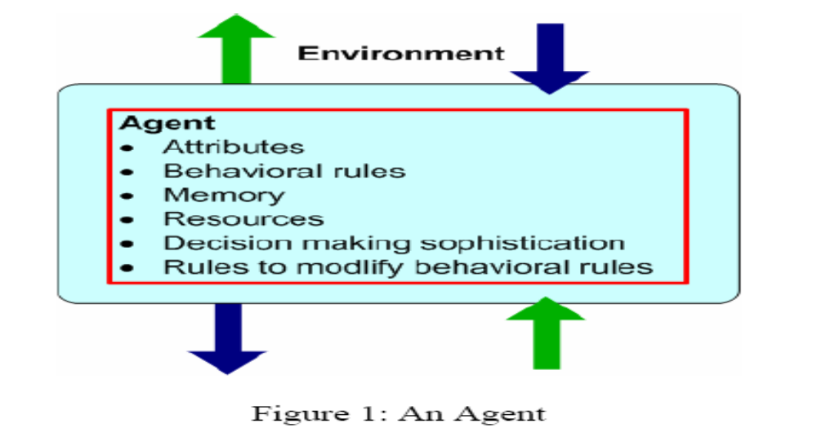

Basic Features that Differentiate Agent from Object

Software agents have their own thread of control, localizing not only code and state but their invocation as well . Such agents can also have individual rules and goals, making them appear like "active objects with initiative". In other words, the agent determines when and how an agent acts. Agents are commonly regarded as autonomous entities, because they can watch out for their own set of internal responsibilities. Furthermore, agents are interactive entities that are capable of using rich forms of messages. These messages can support method invocation as well as informing the agents of particular events, asking something of the agent, or receiving a response to an earlier query. Again as agents are autonomous they can initiate interaction and respond to a message in any way they choose. In other words, agents can be thought of as objects that can say "No" - as well as "Go"[2]. Due to the interactive and autonomous nature of agents, little or no interaction is required to physically launch an application. "In the ultimate agent vision, the application developer simply identifies the agents desired in the final application, and the agents organize themselves to perform the required functionality." No centralized

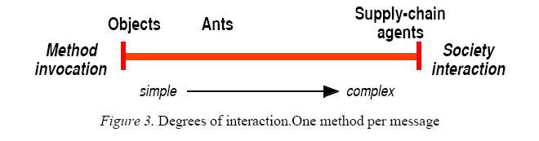

thread or top-down organization is necessary since agent systems can organize themselves.

Characteristics Of Agents:

Software agents have the following properties, which distinguish them from other programs:

Intelligence: Software agents employ techniques from the field of artificial intelligence, which empower them with a fair degree of intelligence and common sense. For example, the travel agent program should realize that people generally do not prefer
travelling by flights that depart or arrive at the airport late in the night and the agent should avoid booking tickets on such flights. The travel agent program should be smart enough to bargain and arrange the trip so that the overall expenditure for the trip is as low as possible without compromising on the user’s preferences.

Autonomy: The agents themselves decide the sequence of actions to be performed to achieve the user’s task. This autonomy enables agents to operate without requiring human intervention. Once the specifications are given to the travel agent, it should be able to proceed on its own to arrange the trip for the user without requiring the user to constantly monitor the agent.

Responsiveness: Agents perceive their environment (which may be the Internet, a collection of other agents, etc.) and respond in a timely fashion to changes that occur in it. At the same time, agents should not simply act in response to their environment, they should be able to exhibit opportunistic, goal-oriented behaviour and take the initiative when appropriate.

Communicative Ability: Software agents should provide a user friendly interface so that the user can easily interact with the agent. Agents are social entities and often communicate and collaborate with one another in order to complete their tasks. For example, the travel agent program of one user must be able to communicate with other travel agents to find out about hotels which customers disliked and avoid such hotels.

Adaptability: Agents learn about the user’s behavior and adapt themselves to suit the user. Consider a search agent that retrieves information for the user from the Internet. The search agent should be able to learn about the type of information the user is interested in and adapt itself to deliver only the relevant information to the user.

Mobility: Software agents can be classified as static agents and mobile agents. Static agents achieve their goal by executing on a single machine. On the other hand, mobile agents migrate from one computer to another in the network and execute on several machines.

Agent Based Technology (ABT)

An Agent Based Technology ( also called Multi agent System ) is a class of computational models for simulating the actions and interactions of autonomous agents with a view of assessing their effects on the system as a whole.

In Agent Based Technology , a system is modeled as a collection of autonomous decision making entities – called agents.

Working of Mobile Agent:

A mobile agent consists of the program code and the program execution state (the current values of variables, next instruction to be executed, etc.). Initially a mobile agent resides on a computer called the home machine. The agent is then dispatched to execute on a remote computer called a mobile agent host (a mobile agent host is also called mobile agent platform or mobile agent server). When a mobile agent is dispatched the entire code of the mobile agent and the execution state of the mobile agent is transferred to the host.
The host provides a suitable execution environment for the mobile agent to execute. The mobile agent uses resources (CPU, memory, etc.) of the host to perform its task. After completing its task on the host, the mobile agent migrates to another computer. Since the state information is also transferred to the host, mobile agents can resume the execution of the code from where they left off in the previous host instead of having to restart execution from the beginning. This continues until the mobile agent returns to its home machine after completing execution on the last machine in its itinerary.

Life Cycle of Mobile Agent:

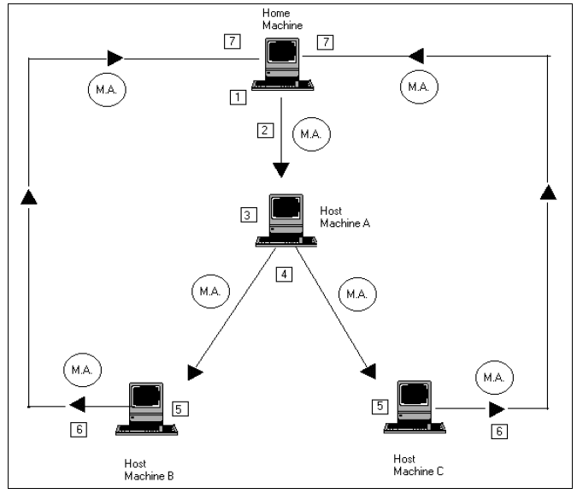

- The mobile agent is created in the Home Machine.

2. The mobile agent is dispatched to the Host Machine A for execution.

3. The agent executes on Host Machine A.

4. After execution the agent is cloned to create two copies. One copy is dispatched to Host Machine B and the other is dispatched to Host Machine C.
5. The cloned copies execute on their respective hosts.

6. After execution, Host Machine B and C send the mobile agent received by them back to the Home Machine.

7. The Home Machine retracts the agents and the data brought by the agents is analyzed. The agents are then disposed.

From this we observe that a mobile agent experiences the following events in its life cycle: [3]

Creation: a brand new agent is born and its state is initialized.
Dispatch: an agent travels to a new host.
Cloning: a twin agent is born and the current state of the original is duplicated in the clone.
Deactivation: an agent is put to sleep and its state is stored on a disk of the host.
Activation: a deactivated agent is brought back to life and its state is restored from disk.
Retraction: an agent is brought back from a remote host along with its state to the home machine.

Advantages Of Mobile Agent:

- Network Load Reduction: The interactions in a distributed system
are often achieved using communication protocols. These protocols involve transfer of large volumes of data stored at remote hosts over the network to a central processing site resulting in high network traffic. Mobile agents are dispatched to the remote hosts containing the data. The agents perform the computations at the remote hosts and return back with the results. Since computations are moved to the data storage location instead of moving data to the computing location, network load is reduced.

- Overcome Network Latency: Consider a manufacturing plant in which many critical real time systems are controlled through a network. Controlling many systems through a network involves significant delays, which are not acceptable for critical real time systems. To overcome this problem, mobile agents can be directly dispatched from the central controller in the manufacturing plant to the real time systems. The agents act locally and directly execute the controller’s directions.

- Protocol Encapsulation: Protocols enable components of a distributed system to communicate and co-ordinate their activities. However, protocols evolve over a period of time and new features such as better security may be introduced in the protocol. It is a cumbersome task to upgrade the protocol code at all locations in the distributed system. Mobile agents offer a solution to this problem. The mobile agent code can encapsulate the protocol. When a protocol is upgraded, only the mobile agent has to be altered.

- Asynchronous & Autonomous Execution: Mobile agents operate asynchronously. Once a mobile agent is dispatched from the home machine, the home machine can disconnect from the network. The mobile agent executes autonomously without the intervention of the home machine. The home machine can reconnect at a later time and collect the agent.

- Fault Tolerance: Mobile agents react dynamically and autonomously to the changes in their environment, which makes them robust, and fault tolerant. They have the ability to distribute themselves in the network in such a way as to maintain the optimal configuration for solving the particular problem. If a host is being shut down, all agents executing on that machine will be warned and given time to dispatch themselves and continue their operation on another host in the network.

Disadvantages Of Mobile Agent:

The main drawback of mobile agents is the security risk involved in using mobile agents. Security risks in a mobile computing environment are two fold:

- Firstly a malicious mobile agent can damage a host. For example, a virus can be disguised as a mobile agent and distributed in the network causing damage to the host machines that execute the agent.

- On the other hand a malicious host can tamper with the functioning of the mobile agent. Most experts suggest that this risk is far more difficult to deal with.

Applications of ABT:

- Parallel Computing: Solving a complex problem on a single computer takes a lot of time. To overcome this, agents can be written to solve the problem. These agents migrate to computers on the network, which have the required resources and use them to solve the problem in parallel thereby reducing the time required to solve the problem.

- E-Commerce: Mobile agents can travel to different trading sites and help to locate the most appropriate deal, negotiate the deal and even finalize business transactions on behalf of their owners. A mobile agent can be programmed to bid in an online auction on behalf of the user. The user himself need not be online during the auction.

- Mobile Computing: Wireless Internet access is likely to stay slow and expensive. Power consumption of wireless devices and high connection fee deter users from staying online while some complicated query is handled on behalf of the user. Users can dispatch a mobile agent, which embodies their queries, and log off, and the results can be picked up at a later time.

Case Study: Supplier System

A supply chain consists of five stages: factories, distributors, wholesalers ,and retailers who respond to customers’ demand. Multiple agents of each type exist at each stage forming a network of supply chain agents: [1]

1. The customer places an order with the retailer.
2. The retailer fills the order immediately from its respective inventory if it has enough inventory in stock (if the retailer runs out of stock, the customer’s order is placed on backorder and filled when stock is replenished).
3. The retailer receives a shipment from the upstream wholesaler in response to previous orders. The retailer then decides how much to order from the wholesaler based on an “ordering rule.”

4. Similarly, each wholesaler receives a shipment from the upstream distributor, forecasts future demand by the downstream retailer, and places an order with the distributor. This process continues up the chain to the factory who decides on how much to put into new production.

Objective :

The goal of the supply chain agents, other than customers, is to manage their inventory in such a way as to minimize their costs through judicious decisions based on how much to order each period. When inventories are too low and there is a danger of running out of stock, agents order more; when inventories are too large and agents incur high inventory holding costs, agents order less.

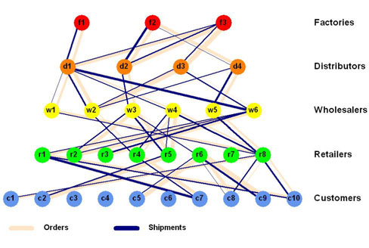

Building the Supply Chain System:

Step-1: One begins developing an Agent Based model by identifying the agent types and other objects (classes) along with their attributes. In the supply chain model, the supply chain agents consist of factory, distributor, wholesaler, retailer and customer agents. The distributor, wholesaler, and retailer agents are grouped together in a class called “middle Agents” because they all have the same structure in terms of their attributes and the methods.

Step-2: One then specifies the environment in which the agents live and interact

Step-3: Next, one specifies the methods by which agent attributes are updated during the simulation in response to either agent-to-agent interactions or agent interactions with the environment

Step-4: One then adds the methods that control which agents interact, when they interact, and how they interact

Step-5 :One implements an agent model by either writing an object-oriented program using, for example, JAVA.

References:

- TUTORIAL ON AGENT-BASED MODELING AND SIMULATION PART 2: HOW TO MODEL WITH AGENTS.
Charles M. Macal, Michael J. North
Center for Complex Adaptive Agent Systems Simulation(CAS2)
Decision & Information Sciences Division, Argonne National Laboratory, Argonne, IL 60439, U.S.A.
Proceedings of the 2006 Winter Simulation Conference
L. F. Perrone, F. P. Wieland, J. Liu, B. G. Lawson, D. M. Nicol, and R. M. Fujimoto, eds.

2. COMPLEX ADAPTIVE SYSTEMS
James Odell
jodell@compuserve.com
www.jamesodell.com

3. Mobile Agents-Intelligent Assistants on the Internet
Parineeth M Reddy
RESONANCE July 2002

